TITLE OF THE PAPER

A.B. Silva¹, C. Muñoz², D. Schmidt¹, E. Castro³

1) First affiliation (including full address of Institution)
2) Second affiliation (if different).
3) Third affiliation (if different).

Every paper for publication must be preceded by an abstract setting out the essential contents. Use A4 paper size, with 1" margins on all sides. A required 200-250 word abstract starts on this line. Leave two blank lines before and after the “ABSTRACT”. Use 10 point Times New Roman in bold and single spacing. The abstract is a very brief summary highlighting main accomplishments, what is new, and how it relates to the state-of-the-art.

Keywords: archaeometry, X-ray fluorescence, ceramics

INTRODUCTION

Paper starts here with two blank lines before and one blank line after the section title. Use A4 paper size, with 1" margins on all sides. Section titles have style “Times New Roman”, are 12 point font, must be all uppercase and in bold. Text in single-space with “Times New Roman” style 12. Introduce the topic of your work in this section.

SECOND OR SUBSEQUENT MAJOR HEADING

The paper must be send as a .doc file for the proceedings that will be converted in a .pdf file. Note that it is the author’s responsibility to review the final PDF version of the paper to ensure proper translation into PDF. Recommended paper length is 3 to 6 pages.
Figures and tables should appear as closely as possible to where they are first cited, e.g. Fig. 1, in the text. Figures are numbered in Arabic numerals, with the caption justified below the figure. The name of the figure must be in boldface. Singe-space before the figure, and after the figure caption.
Tables, like Table 1, are numbered in Arabic numerals, with the caption justified above the table. The name of the table must be in boldface. Single-space before and after the table.

Table 1. Numerical results to the model problem
Mesh | 8 x 8ª | 16 x 16 | 32 x 32 | 64 x 64
Nodal | 1.000 10⁻¹ | 2.500 10⁻² | 6.250 10⁻³ | 1.563 10⁻³
Characteristic | 1.000 10⁻¹ | 2.500 10⁻² | 6.250 10⁻³ | 1.563 10⁻³
a. 8 spatial cells in x direction and in y direction.

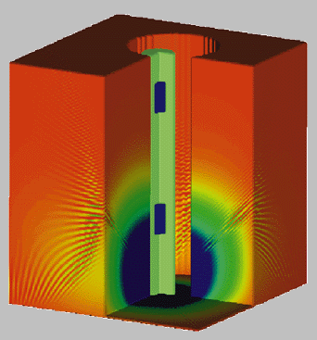
Figure 1. Water-filled borehole using conventional discrete ordinates formulation for the transport equation.

CONCLUSIONS

Present your summary, list your concluding remarks and suggestions for future work here.

Acknowledgements
These are placed at the end of the text, preceding the references, and should be brief.

REFERENCES
References should be cited by superior numbers and listed at the end of the paper in the order in which they appear in the text. All references must be complete and accurate. Online citations should include date of access. If necessary, cite unpublished or personal work in the text but do not include it in the reference list. References should be listed in the following style:
- (for a journal) Malzer W, Hahn O, Kanngiesser B. X-Ray Spectrom. 2004; 33: 229-233.
- (for a book) Janssens KHA, Adams FCV, Rindby A. (eds.). Microscopic X-ray Fluorescenc Analysis. John Wiley & Sons: Chichester, 2000.
- (for a chapter within a book) Hegedüs LS. Palladium in organic synthesis. In Organometallics in Synthesis - A Manual, Schlosser M (ed). Wiley: Chichester, 1994; 383-459.
- (for a website) The Oncology Website. 1999. http://www.wiley.com/oap/ [1 April 1999].
(Journal title abbreviations should follow the American Chemical Society system, listed in The ACS Style Guide).

